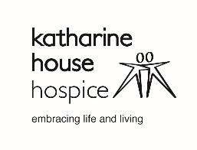

Job Ref: RDMS03

**EQUAL OPPORTUNITIES MONITORING FORM**

Information for the Applicant:

Katharine House Hospice seeks to employ people only on the basis of their competence to undertake the role for which they have applied. We try to ensure our selection processes are not influenced by a candidate’s age, gender, marital status, religion, or ethnicity. Further, we seek not to discriminate against people with disabilities.

We ask you to complete this form when you return your application. This will be opened and retained by the Personnel Department and used for statistical purposes only to enable us monitor adherence to our equal opportunities policy.

**Please do not enter any personal details on this form.**

**1. How would you describe your ethnic origin:**

Afro – Caribbean  White British

African  Other European

Indian  Middle Eastern

Pakistani  Far Eastern

Other or Mixed Descent  Prefer not to say

**2. You are**:  Male  Female  Non Binary  Prefer not to say

**3. Your age is:**  16 – 25  26 – 40  41 – 55  55 – 65  66+

**4. Marital Status** (Please State): __________________________

**5. Religion** (Please State): __________________________

**6. Sexual Orientation** (Please State): __________________________

**7. Has your gender been reassigned?**  Yes  No

**8. Are you registered disabled?**  Yes  No

**9. Do you have an unregistered disability?**  Yes  No

If you have answered **Yes** to questions 8 and/or 9 please state the nature of your disability:

________________________________________________________________________

**10. Please indicate how you heard of this post** _______________________________

**If online, please state which website**_____________________________________