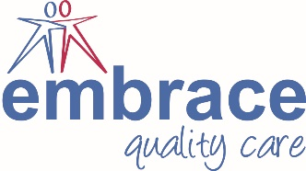 Embrace Quality Care

Independent Director Declaration of Eligibility

Please complete the information below and return to the Personnel Department in an envelope marked ‘Private and Confidential’.

I ______________________________ declare that:

- I am over age 18
- I have not been convicted of any offence of dishonesty or deception
- I am not an undischarged bankrupt
- I have not made compositions with my creditors that have not been discharged
- I have not previously been removed a directorship by a court
- I am not disqualified from being a company director
- I have not failed to make payments under the County Board of Governors Administration Orders
- I am not under a disqualification order under the Company Directors’ Disqualification Act 1986
- I am not disqualified by the Charities Act 1993 (section 72) from acting as a charity trustee
- I undertake to fulfil my responsibilities and duties as an Independent Director of Embrace Quality Care in good faith and in accordance with the law
- I do not have any financial interests in conflict with those of Embrace Quality Care (either in person or through family or business connections) except those I have formally notified to Embrace Quality Care or by virtue of an employment or partnership arrangement of which the company is aware. I will specifically notify any such interest at any meeting where Independent Directors are required to make a decision which affects my personal interests, and I will absent myself entirely from any decision on the matter and not vote on it
- I have not been the subject of any disciplinary action or sanctions relating to abuse of children or vulnerable adults. I am not known to any social services department as being an actual or potential risk to children or vulnerable adults

You are advised that under the provision of the Rehabilitation of Offenders 1974 (Exceptions) Order 1975 as amended by the Rehabilitation of Offenders Act 1974 (Amendment) 1986, you should declare all convictions (including spent convictions). If you are unable to agree with any of the above statements, please speak to the Chief Executive as soon as possible, and leave this form unsigned.

I will take all necessary steps to enable an Enhanced Disclosure and Barring Service (DBS) check to be carried out at the earliest opportunity.

Signed: ___________________________________ Date: __________________

