Katharine House Hospice Risk Assessment for: Large Shops
Date Completed: 14th June 2020 Completed By: Kerry Wright (Retail Health & Safety Officer)
Activity | Person at Risk | Significant Hazard | Risk |  |  | Risk Control Measures | Residual Risk
 |  |  | L | S | DR |  | L | S | DR
Staff/ Volunteers who are classed as clinically extremely vulnerable | Staff  Volunteers | - Higher chance of contracting the virus | 5 | 5 | 25 | - Staff/ volunteers advised to remain shielding away from the organisation until updated guidelines from the Government | 1 | 5 | 5
Staff/ Volunteers who are classified as clinically vulnerable | Staff  Volunteers | - High chance of contracting the virus | 5 | 5 | 25 | - Staff/ volunteers will undergo a risk assessment to identify the ‘safest way for them to return to work’ and are encouraged to discuss/identify opportunities for us to enable this to happen. | 3 | 5 | 15
Entrance/ Exit of Store | Staff  Volunteers  Customers | - People entering all together  - People not respecting the social distancing guidelines | 3 | 5 | 15 | - One way in and one way out (this may need adapting for each individual shop)  - Staff member to be on entrance to control flow of customers - staff here will be expected to wear face covering and/ or visors, also high viz vest  - Customers to sanitise hands before entering | 2 | 5 | 10
Store floor Area/ Office/ Kitchen | Staff  Volunteers  Customers | - Overcrowding on store floor  - Risk of virus transmission through coughing and touching of products/ cash | 4 | 5 | 20 | - Follow number restrictions for each store  - Follow walkway directions  - Staff to ensure social distancing being maintained  - Stop entrance if needs be to give time for store to become safe again  - Staff and volunteers to be encouraged to wear a face covering and/ or visor  - Staff must wear disposable gloves when on the till and clean when moving from here  - Staff must wear disposable gloves when cashing up  - Internal office and kitchen doors to be wedged open- where safe to do so | 3 | 5 | 15
Browsing/ Buying of Furniture | Staff  Volunteers  Customers | - Different customers/ staff/ volunteers touching the furniture passing on virus | 3 | 5 | 15 | - Please do not touch/ sit signs on furniture  - When furniture is being taken to customer’s car staff are to lift only, they must not lift with the customer. If the customer wishes to carry it themselves staff must not offer to help.  - Do not touch anything when you return to the store and wash hands immediately | 2 | 5 | 10
Cleaning | Staff  Volunteers | - Transmission of the virus if cleaning is not properly undertaken | 4 | 5 | 20 | - Staff to be trained on cleaning to prevent infection  - Staff and volunteers to follow a check sheet of what and when cleaning needs to occur- see attached sheet. This will be returned to the Health & Safety Officer to keep a record of cleaning being undertaken  - High risk areas (phones, tills, Gift Aid tablet, handles, toilet handles, kitchen area) to be cleaned after ever use | 3 | 5 | 15
Replenishing stock on store floor | Staff  Volunteers | - Social distancing rules not being followed as staff will be moving furniture meaning walk ways will be blocked | 3 | 5 | 15 | - Replenishing stock will happen at the beginning of the day only | 2 | 5 | 10
Sorting areas | Staff  Volunteers | - Standing closer than the social distancing guidelines  - Donated stock- transmission of the virus | 4 | 5 | 20 | - Ensure gloves are worn when sorting- change gloves regularly and wash hands before putting new gloves on  - Empty bag on to work station first- never put your hands in the bag of donations  - Follow social distancing rules  - Sort side to side or back to back- not facing each other  - Do NOT move from one station to another without an area being cleaned | 3 | 5 | 15
Outside Signage | Staff  Volunteers  Customers  Donors | - Staff/ Volunteers/ Customers/ Donors not aware of the guidelines for the shop, which would put everyone at risk of the virus | 3 | 5 | 15 | Signage for customers will be at the entrance of the store stating:  - Use the sanitizer on entering the shop  - Whilst inside please wear a face cover  - Maintain the social distancing guidelines  - Follow the one-way system  - Go around as a group keeping your children with you  - Follow the directions given by a member of our team  - Please try and avoid from touching items unless you wish to purchase them  - Please pay by card/contactless | 2 | 5 | 10
Customers | Staff  Volunteers  Customers  Donors | - Customers coughing within the store and transmitting the virus | 4 | 5 | 20 | - Customers will be required to wear face coverings. This will be on the entrance notice and customers will be reminded of this by the staff member on the door- customers should still follow social distancing guidelines too | 3 | 5 | 15
Changing Rooms/ Toilets closed/NB Café closed | Staff  Volunteers  Customers | - Customers trying on clothing and not buying clothes- the virus could potentially be transmitted through the clothing to other customers | 3 | 5 | 15 | - Changing rooms to be closed  - Café to be closed, this is following government guidelines  - AS the Café is not open, customer toilet will remain closed | 1 | 5 | 5
External Contractors | Staff  Volunteers  Customers | - Social distancing guidelines not being followed and virus being transmitted | 4 | 5 | 20 | - Not to be on site unless prior arrangement with Area Managers  - Depending on the work- the area will need to be blocked off and staff need to adjust walkway system, still ensuring social distance and the one way system. Contractors will also need to follow this risk assessment (walkways, face covering, sanitising hands)  - Ideally contractors not to be carrying out work during store opening times  - RAG to be sent to Central Place for storage and collection | 3 | 5 | 15
Donations | Staff  Volunteers  Customers  Donors | - Donations coming from houses where the virus could have been  - Donors not following social distance guidelines | 4 | 5 | 20 | - Donations to be placed into specific storage containers and quarantined or 72 hours before being sorted or placed on to store floor  - Donors will place their own donations into the containers  - Staff will control the flow of donors, ensuring social distancing rules as well as face coverings  - Staff in charge of donations must wear face shields and/or visors, disposable gloves and high viz  - If the staff member needs to move any stock in the container due to Health & Safety concerns they must remove their gloves, sanitise their hands and then wear new disposable gloves | 3 | 5 | 15
Job Roles | Staff  Volunteers | - Staff becoming tired in the same role and could forget to reinforce and implement guidelines and safety meaning everyone is at risk | 4 | 5 | 20 | - Store Management Team to rotate staff roles regularly  - Staff to cover all roles needed at some point during the shift  - If on a station or the till these need to be cleaned before leaving | 3 | 5 | 15
Breaks | Staff  Volunteers | - People not respecting the social distancing guidelines  - Sharing of crockery  - Sharing of food | 3 | 5 | 15 | - Staff will take their breaks at given times respecting the number who can be within the break space to maintain safety  - Staff will use their own cups/ crockery and wash these up straight away after use  - Surfaces they touch, chairs, table will be wiped using the cleaning products provided after use | 2 | 5 | 10
Fire Evacuation | Staff  Volunteers  Customers  Donors | - Severe injury or death | 5 | 5 | 25 | - Follow stores individual Fire Evacuation Procedure which would have been discussed at the New Induction Session | 3 | 5 | 15

LIKELIHOOD (L) Almost Certainty (5) Likely (4) Possible (3) Unlikely (2) Rare (1)
SEVERITY(S) Catastrophic (5) Major (4) Moderate (3) Minor (2) Insignificant (1)
Degree of risk (DR) = LIKELIHOOD X SEVERITY Low = 1-3 Medium = 4-6 Significant = 5-12 High= 15-25
*Residual risk is the level of risk that remains after suitable and sufficient control measures are introduced.
Assessor’s signature: K. Wright Date completed: 14th June 2020
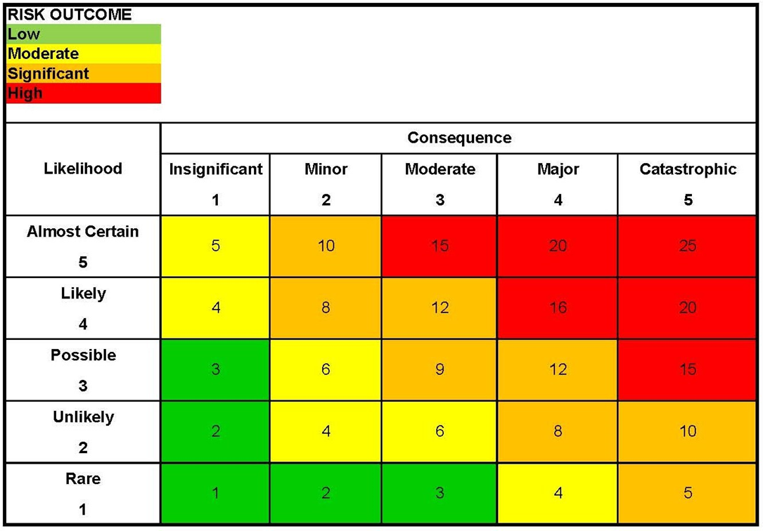
Assessed signature: P. Costen (Health & Safety Manager)
(if applicable)

Date of Review: Daily Review will occur once shops open and in accordance with changing Government Guidelines

